PLSQL PROGRAM STRUCTURE

TYPES OF PROGRAMS

ANONYMOUS TYPE PROGRAM STRUCTURE

STATIC PROGRAMS EXAMPLES.

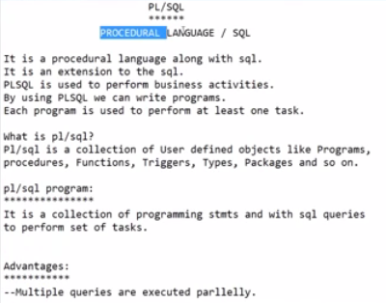

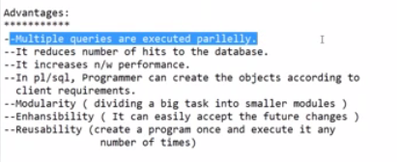

SQL HITS THE BD AT ONCE FOR SINGLE QUERY.

PLSQL ALSO HITS THE BD AT ONCE FOR MULTIPLE QUERY

IN PLSQL WE CAN ALSO USE SQL STATEMENTS.

WE CREATE PROCEDURES IN PLSQL

PROCEDURE IS ALSO A PROGRAM, SET OF STATEMENTS TO PERFORM A TASK.

WE CAN COMMUNICATE WITH DB WITH SET OF STATEMENTS, BUT SQL WITH ONE STATEMENT.

WE CAN GET DATA FROM DB BY WRITING SELECT QUERY ONLY.

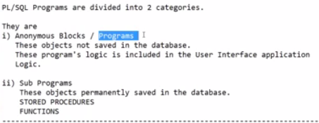

ANONYMOUS BLOCKS ARE USED TO CALL THE SUB PROGRAMS.

1. IS AT CLIENT LEVEL.
2. IS AT SERVER SIDE PROGRAMS

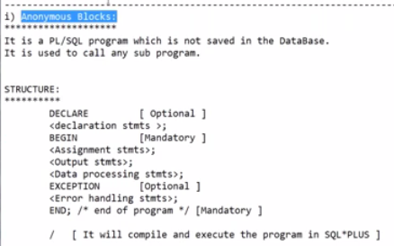

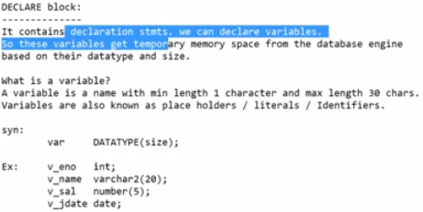

VARIABLE NAMES ARE REFERENCES FOR MEMORY LOCATIONS

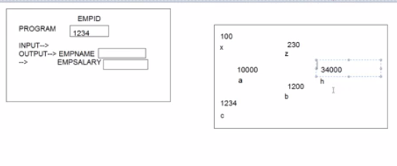

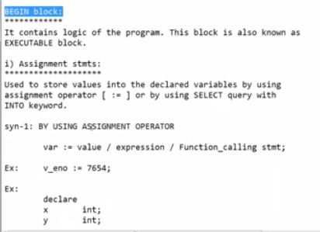

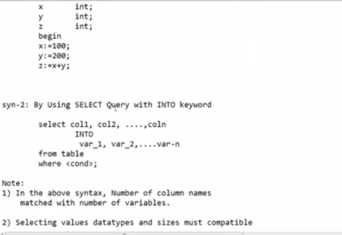

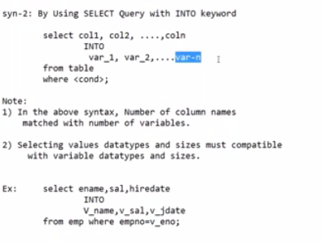

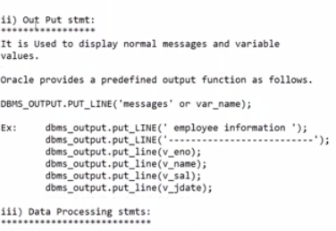

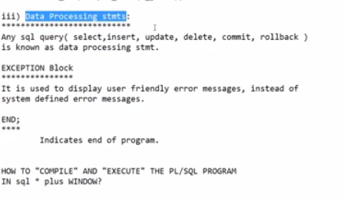

DON’T USE DDL COMMANDS IN ii

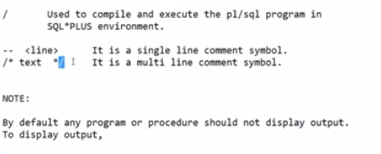

SQL> --WRITE A PROGRAM TO DISPLAY WELCOME TO PLSQL MESSAGE ?

SQL> BEGIN

2 DBMS_OUTPUT.PUT_LINE('WELCOME TO PLSQL')

3 END;

4 /

END;

*

ERROR at line 3:

ORA-06550: line 3, column 1:

PLS-00103: Encountered the symbol "END" when expecting one of the following:

:= . ( % ;

The symbol ";" was substituted for "END" to continue.

SQL> ED

Wrote file afiedt.buf

1 BEGIN

2 DBMS_OUTPUT.PUT_LINE('WELCOME TO PLSQL');

3* END;

SQL> /

PL/SQL procedure successfully completed.

SQL> --OUTPUT NOT DISPLAYED

SQL> SET SERVEROUTPUT ON;

SQL> /

WELCOME TO PLSQL

PL/SQL procedure successfully completed.

SQL> -- WRITE A PROG TO DISPLAY TOTAL SALARY PAYING TO ALL EMPS.

SQL> BEGIN

2 TOTSAL NUMBER(10);

3 /

TOTSAL NUMBER(10);

*

ERROR at line 2:

ORA-06550: line 2, column 8:

PLS-00103: Encountered the symbol "NUMBER" when expecting one of the following:

:= . ( @ % ;

The symbol ":=" was substituted for "NUMBER" to continue.

ORA-06550: line 2, column 18:

PLS-00103: Encountered the symbol "end-of-file" when expecting one of the

following:

( begin case declare end exception exit for goto if loop mod

null pragma raise return select update while with

<an identifier> <a double-quoted

SQL> DECLARE

2 TOTSAL NUMBER(10);

3 BEGIN

4 SELECT SUM(SAL) INTO TOTSAL FROM EMP;

5 END;

6 /

PL/SQL procedure successfully completed.

SQL> ED

Wrote file afiedt.buf

1 DECLARE

2 TOTSAL NUMBER(10);

3 BEGIN

4 SELECT SUM(SAL) INTO TOTSAL FROM EMP;

5 DBMS_OUTPUT.PUT_LINE('TOTAL SALARY OF ALL EMPLOYEES IS :' ||TOTSAL);

6* END;

SQL> /

TOTAL SALARY OF ALL EMPLOYEES IS :29025

PL/SQL procedure successfully completed.

SQL> -- WRITE A PROG TO DISPLAY EMP NAME SAL DESG OF EMPID 7788

SQL> BEGIN

2 /

BEGIN

*

ERROR at line 1:

ORA-06550: line 1, column 5:

PLS-00103: Encountered the symbol "end-of-file" when expecting one of the

following:

( begin case declare exit for goto if loop mod null pragma

raise return select update while with <an identifier>

<a double-quoted delimited-identifier> <a bind variable> <<

continue close current delete fetch lock insert open rollback

savepoint set sql execute commit forall merge pipe purge

SQL> DECLARE

2 VNAME VARCHAR2(10),

3 VSAL NUMBER(10),

4 VDESG VARCHAR2(10)

5 BEGIN

6 SELECT ENAME, SAL, DESG INTO VNAME, VSAL, VDESG FROM EMP WHERE EMPID=7788;

7 DBMS_OUTPUT.PUT_LINE('EMP NAME IS : '||VNAME||CHR(10)||'EMP SALARY IS : '||VSAL||CHR(10)||'EMPLOYEE DESIGNATION IS : '||VDESG);

8 END;

9 /

VNAME VARCHAR2(10),

*

ERROR at line 2:

ORA-06550: line 2, column 19:

PLS-00103: Encountered the symbol "," when expecting one of the following:

:= ; not null default character

ORA-06550: line 5, column 1:

PLS-00103: Encountered the symbol "BEGIN" when expecting one of the following:

:= , ; not null default external character

The symbol ";" was substituted for "BEGIN" to continue.

SQL> ED

Wrote file afiedt.buf

1 DECLARE

2 VNAME VARCHAR2(10),

3 VSAL NUMBER(10),

4 VDESG VARCHAR2(10)

5 BEGIN

6 SELECT ENAME, SAL, DESG INTO VNAME, VSAL, VDESG FROM EMP WHERE EMPID=7788;

7 DBMS_OUTPUT.PUT_LINE('EMP NAME IS : '||VNAME||CHR(10)||'EMP SALARY IS : '||VSAL||CHR(10)||'EMPLOYEE DESIGNATION IS : '||VDESG);

8* END;

SQL> ED

Wrote file afiedt.buf

1 DECLARE

2 VNAME VARCHAR2(10);

3 VSAL NUMBER(10);

4 VDESG VARCHAR2(10);

5 BEGIN

6 SELECT ENAME, SAL, DESG INTO VNAME, VSAL, VDESG FROM EMP WHERE EMPID=7788;

7 DBMS_OUTPUT.PUT_LINE('EMP NAME IS : '||VNAME||CHR(10)||'EMP SALARY IS : '||VSAL||CHR(10)||'EMPLOYEE DESIGNATION IS : '||VDESG);

8* END;

SQL> /

SELECT ENAME, SAL, DESG INTO VNAME, VSAL, VDESG FROM EMP WHERE EMPID=7788;

*

ERROR at line 6:

ORA-06550: line 6, column 64:

PL/SQL: ORA-00904: "EMPID": invalid identifier

ORA-06550: line 6, column 1:

PL/SQL: SQL Statement ignored

SQL> ED

Wrote file afiedt.buf

1 DECLARE

2 VNAME VARCHAR2(10);

3 VSAL NUMBER(10);

4 VDESG VARCHAR2(10);

5 BEGIN

6 SELECT ENAME, SAL, DESG INTO VNAME, VSAL, VDESG FROM EMP WHERE EMPNO=7788;

7 DBMS_OUTPUT.PUT_LINE('EMP NAME IS : '||VNAME||CHR(10)||'EMP SALARY IS : '||VSAL||CHR(10)||'EMPLOYEE DESIGNATION IS : '||VDESG);

8* END;

SQL> /

SELECT ENAME, SAL, DESG INTO VNAME, VSAL, VDESG FROM EMP WHERE EMPNO=7788;

*

ERROR at line 6:

ORA-06550: line 6, column 20:

PL/SQL: ORA-00904: "DESG": invalid identifier

ORA-06550: line 6, column 1:

PL/SQL: SQL Statement ignored

SQL> DESC EMP;

Name Null? Type

----------------------------------------- -------- ----------------------------

EMPNO NOT NULL NUMBER(4)

ENAME VARCHAR2(10)

JOB VARCHAR2(9)

MGR NUMBER(4)

HIREDATE DATE

SAL NUMBER(7,2)

COMM NUMBER(7,2)

DEPTNO NUMBER(2)

SQL> ED

Wrote file afiedt.buf

1 DECLARE

2 VNAME VARCHAR2(10);

3 VSAL NUMBER(10);

4 VDESG VARCHAR2(10);

5 BEGIN

6 SELECT ENAME, SAL, JOB INTO VNAME, VSAL, VDESG FROM EMP WHERE EMPNO=7788;

7 DBMS_OUTPUT.PUT_LINE('EMP NAME IS : '||VNAME||CHR(10)||'EMP SALARY IS : '||VSAL||CHR(10)||'EMPLOYEE DESIGNATION IS : '||VDESG);

8* END;

SQL> /

EMP NAME IS : SCOTT

EMP SALARY IS : 3000

EMPLOYEE DESIGNATION IS : ANALYST

PL/SQL procedure successfully completed.

SQL> ED

Wrote file afiedt.buf

1 DECLARE

2 VNAME VARCHAR2(10);

3 VSAL NUMBER(10);

4 VDESG VARCHAR2(10);

5 BEGIN

6 SELECT ENAME, SAL, JOB INTO VNAME, VSAL, VDESG FROM EMP WHERE EMPNO=7654;

7 DBMS_OUTPUT.PUT_LINE('EMP NAME IS : '||VNAME||CHR(10)||'EMP SALARY IS : '||VSAL||CHR(10)||'EMPLOYEE DESIGNATION IS : '||VDESG);

8* END;

SQL> /

EMP NAME IS : MARTIN

EMP SALARY IS : 1250

EMPLOYEE DESIGNATION IS : SALESMAN

PL/SQL procedure successfully completed.

SQL> /

EMP NAME IS : MARTIN

EMP SALARY IS : 1250

EMPLOYEE DESIGNATION IS : SALESMAN

PL/SQL procedure successfully completed.

SQL> /

EMP NAME IS : MARTIN

EMP SALARY IS : 1250

EMPLOYEE DESIGNATION IS : SALESMAN

PL/SQL procedure successfully completed.

SQL> --IT IS GIVING SAME OUTPUT FOR ALL THE EXECUTIONS BCA I/P IS SAME.

SQL> --SO , WE WILL SEE RUN TIME INPUT VALUES IN NEXT SESSION CALLED DYNAMIC PROGRAMS.

SQL> SPOOL OFF;

--THE FOLLOWING IS SPOOL FILE OF CLASS.

SQL>

SQL> --> write a program to display welcome to plsql message?

SQL>

SQL> BEGIN

2 DBMS_OUTPUT.PUT_LINE('WELCOME TO PLSQL PROGRAMMING');

3 END;

4 /

PL/SQL procedure successfully completed.

SQL> SET SERVEROUTPUT ON;

SQL> /

WELCOME TO PLSQL PROGRAMMING

PL/SQL procedure successfully completed.

SQL> --> write a program to display total salary paying to all emps?

SQL>

SQL> DECLARE

2 VTOTAL number;

3 BEGIN

4 select sum(sal) INTO vtotal

5 from emp;

6 dbms_output.put_line(' Total Salary: ');

7 dbms_output.put_line(vtotal);

8 END;

9 /

Total Salary:

29025

PL/SQL procedure successfully completed.

SQL> ed

Wrote file afiedt.buf

1 DECLARE

2 VTOTAL number;

3 BEGIN

4 select sum(sal) INTO vtotal

5 from emp;

6 dbms_output.put_line(' Total Salary: '||vtotal);

7 --dbms_output.put_line(vtotal);

8* END;

SQL> /

Total Salary: 29025

PL/SQL procedure successfully completed.

SQL>

SQL> --> write a program to display empname,sal, desg of emp id 7788?

SQL>

SQL> DECLARE

2 vname varchar2(10);

3 vsal number(5);

4 vdesg varchar2(10);

5 BEGIN

6 select ename,sal,job into vname,vsal,vdesg

7 from emp

8 where empno=7788;

9 dbms_output.put_line(' Empid: 7788');

10 dbms_output.put_line(' Emp Name: '||vname);

11 dbms_output.put_line(' Emp salary: '||vsal);

12 dbms_output.put_line(' Working as: '||vdesg);

13 end;

14 /

Empid: 7788

Emp Name: SCOTT

Emp salary: 3000

Working as: ANALYST

PL/SQL procedure successfully completed.

SQL> /

Empid: 7788

Emp Name: SCOTT

Emp salary: 3000

Working as: ANALYST

PL/SQL procedure successfully completed.

SQL> /

Empid: 7788

Emp Name: SCOTT

Emp salary: 3000

Working as: ANALYST

PL/SQL procedure successfully completed.

SQL> spool off;